CITY OF MARION CITY PLANNING COMMISSION
STAFF REPORT

December 18, 2018

APPLICANT: Amy and Lakhwinder Singh
OWNER: Amy and Lakhwinder Singh
LOCATION: 111 Superior St / 717 Delaware Ave Marion, Ohio
LOT: Sunoco gas station and convenient store on a .45 acre lot on corner of Superior St and Delaware Ave
ZONING: West half of parcel is zoned R-1C and east half of parcel facing Delaware Ave is zoned C-1B
REQUEST: Rezone the west half of the parcel from R-1C to C-1B to match the east half.

BACKGROUND: The parcel in question is a long time convenient store and gas station. The owner wishes to cut a hole in the west side of the building and expand out 4 feet to place a drive up window for the use of customers. (See sketch attached) The portion of the lot that is currently zoned R-1C will be used as a U-shaped drive to access the window. The area that will be used for drive through lanes would be considered to support a commercial use and in order to comply with the zoning code would need to be rezoned to C-1B.
COMMENT:
In favor of the request, we find that:
- The use of the lot is already commercial.
- Granting the request would be in line with many other businesses that are moving toward models that prioritize customer convenience and could increase access for disabled.
- The portion of the lot that would be used for drive up window access is already paved and would not increase impervious surface.

Against the request, we find that:
- Extra traffic, and headlights may be a nuisance to adjoining property owners to the west that are in the R-1C district.
FURTHER COMMENT:
This application has been submitted along with an application for a variance to allow a drive thru window. RPC staff have recommended to approve that variance upon condition that the west half of the parcel be rezoned to C-1B.
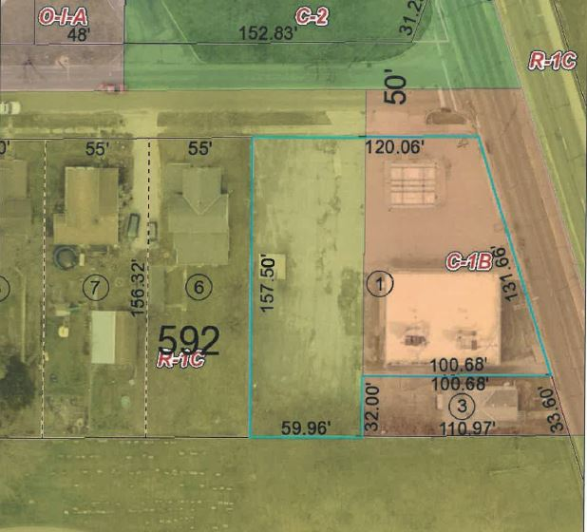
RECOMMENDATION: RPC Staff recommend approving the rezone from R-1C to C-1B
